Insert Qr Scan Code here

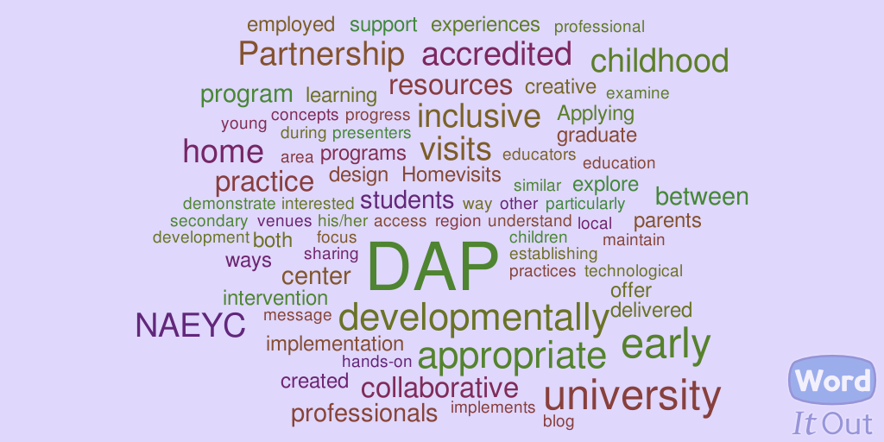

Resources to Consider:

- What Works Clearinghouse: Http://ies.ed.gov/ncee/wwc/
- Universal Design for Learning - Center for Assistive Technology (CAST): http://www.cast.org/
- Framework for customizing technology needs of a child/family: http://www.joyzabala.com/
- Early intervention in natural Environments Blog by
R.A. McWilliam: http://naturalenvironments.blogspot.com/
- Teacher Home Visit program: Http://teacherhomevisit.org/

