FIRST STEPS REGION 1 St. Charles AND LINDENWOOD UNIVERSITY RESEARCH STUDY:
Field Testing the Family Planner as an Android App or as a Graphic Organizer Tool
Now available as an Android app
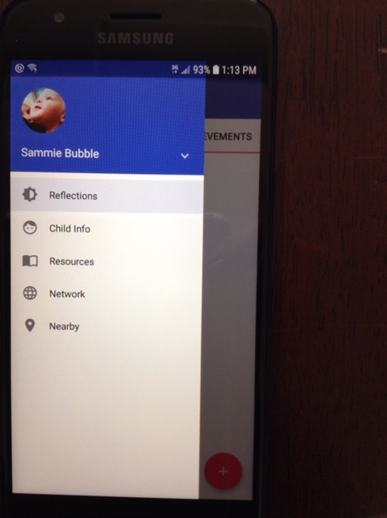
Designed as a “Do It Yourself” graphic organizer for you to
- Analyze and organize resources
-Make more informed decisions
-Advocate for your child and family
-Introduce your child and family to new medical professionals, therapists, providers, educators and caregivers

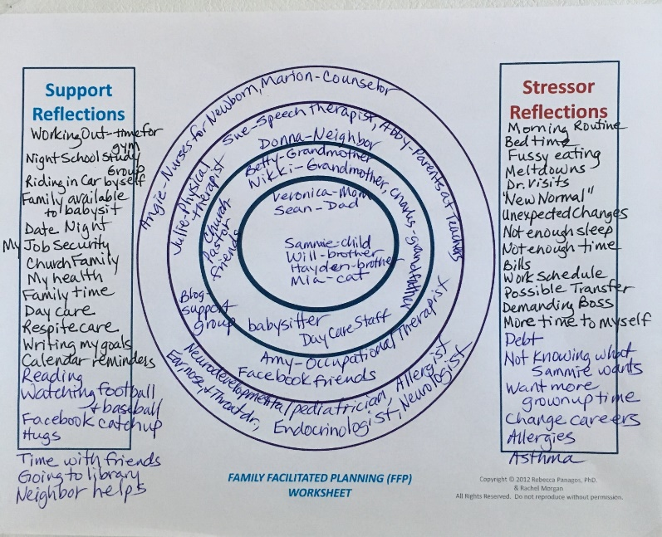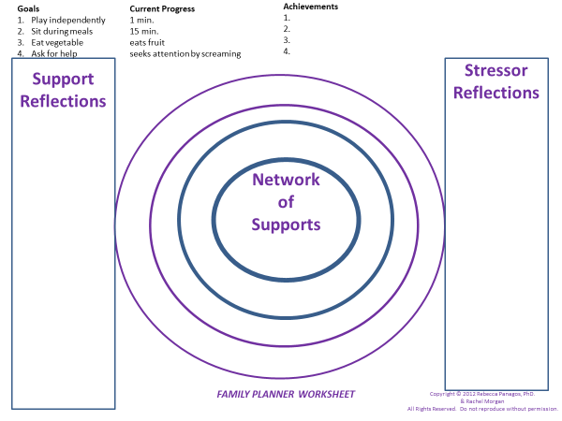

Impacting the fields of early interventions, early childhood special education, autism and developmental disabilities, this research study promotes empowerment by validating a “Do it Yourself” empowerment tool for self-advocacy. Renowned early intervention researcher Robin McWilliam aptly noted, “Currently, we are in an era of empowerment…The current concept of early intervention places a high value on the family’s decision-making authority” (McWilliam, 2010, p. 4-5).

As a participant in this research study, you would
- Give consent for a Lindenwood University research assistant and/or professor to attend home visits over a six week period and future IFSP meetings with First Steps Provider and team members,
- Write and create your own Family empowerment tool either as a Graphic Organizer Tool or as an Android App with the research team and First Steps Provider on a home visit; If working with the Android app, you would download the app on your phone. The app is stored locally and not connected to internet.
- Share the Family Planner (Graphic Organizer on paper or Android app) with your research team and Provider on home visits and at your IFSP (Individual Family Service Plan) meetings;
- Answer survey questions about how you plan to use the organizer in the future and questionnaires integrating family empowerment and family supports from Dr. Panagos and/or research assistant;
- Update the graphic organizer tool or the Android Family Planner app and share updates with the research team, and
- Consider the empowerment tool for use throughout your child’s life.
Please contact:
Dr. Rebecca Panagos
Lindenwood University
636-949-4959
RPanagos@lindenwood.edu



