How to get your Unique Device ID (UDID) from your iPhone?
Step 1: Go to this website
https://get.udid.io/

Step 2:Tap on find UDID
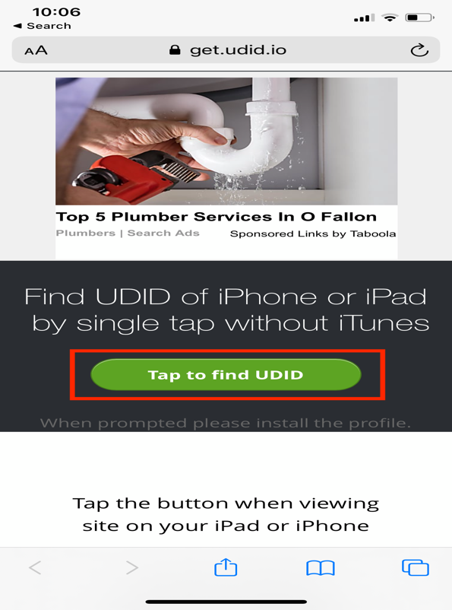
Click on: Tap to find UDID (in green)
There will be a different ad showing here.
Step 3: You should see a pop up like the one shown in the picture below. Click on Allow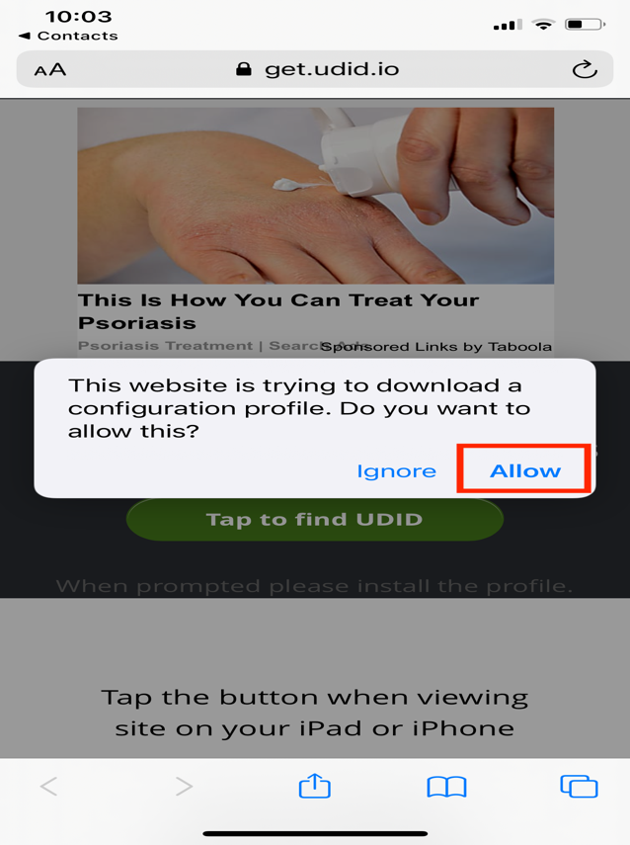
Click on Allow

Step 4: You will see a screen that says profile downloaded as shown in the picture below
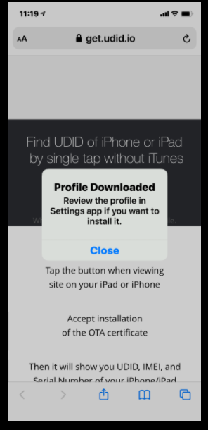
Once you see this message, Open Settings on your phone to see the screen below.

Step 5: Go to Settings on your phone and click on the Profile Downloaded button
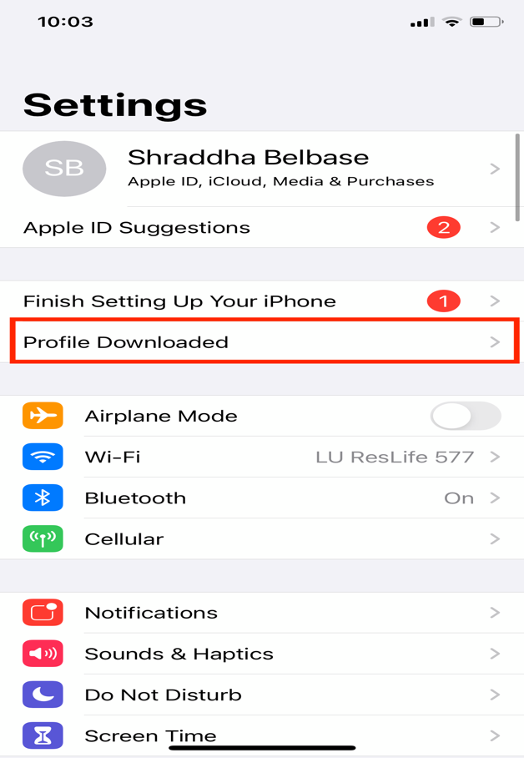
Click on the Arrow to Profile Downloaded.

Step 6: Click Install

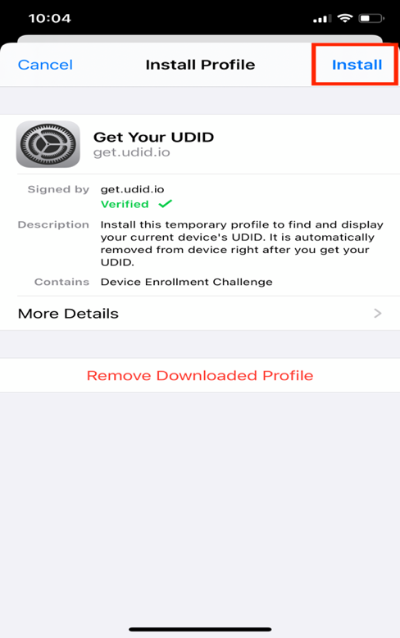
Click Install

Step 7: Confirm installation once again.

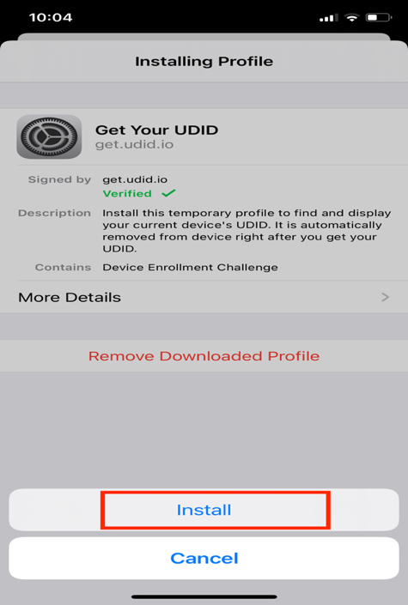

Step 8: Enter your passcode
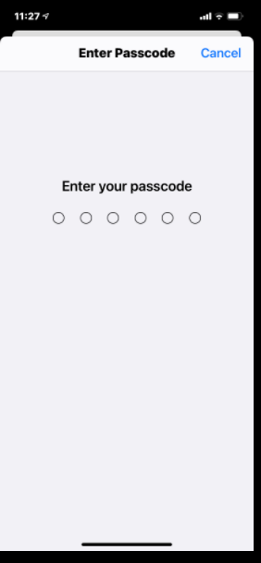
Enter your passcode

Step 9: Click on Accept Installation of the OTA certificate

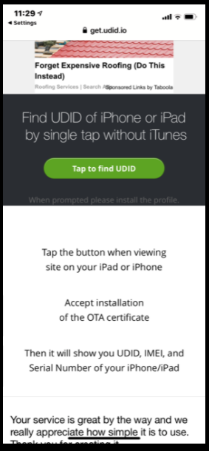
Click on Accept installation of the OTA certificate

Step 10: You should see a page showing your UDID.

